**PROJECT 1**

* **Deploying a web server in Windows instance**

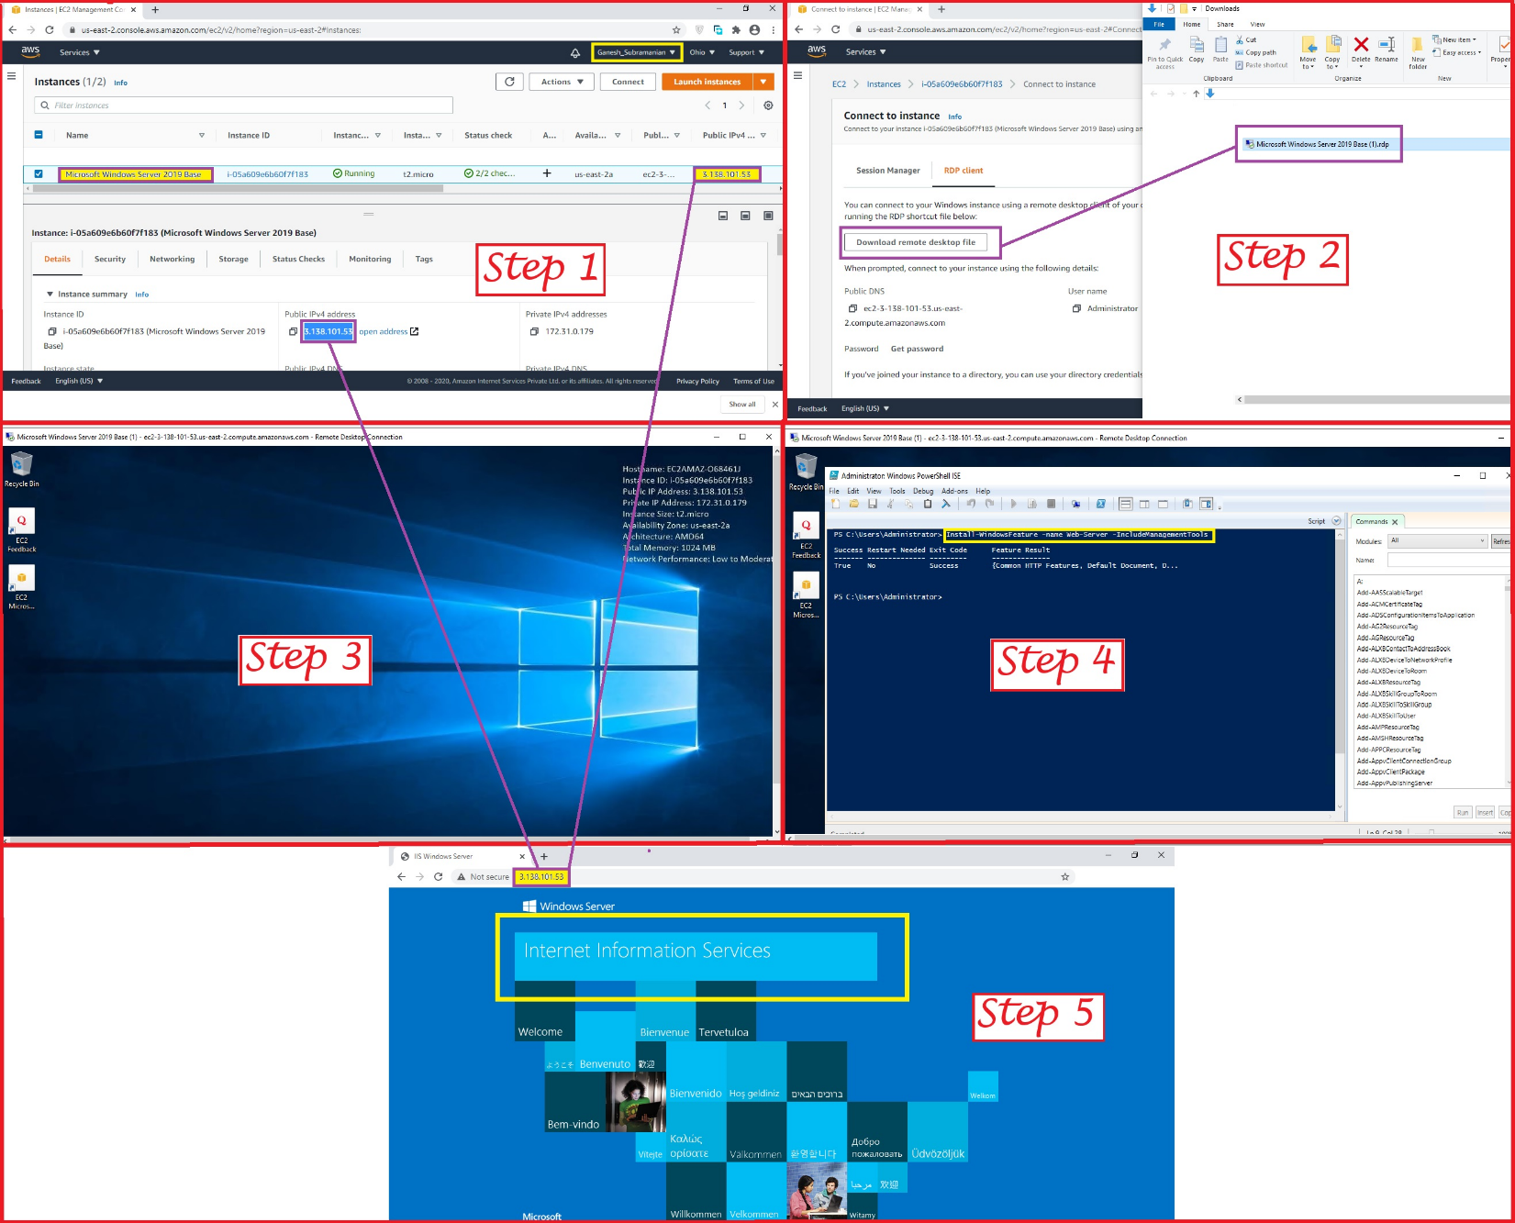

Note: -

As per the assignment given it says Create a Windows instance using AMI of “Windows 2012 R2 Base” Since this doesn’t include in the Free Trial version of AWS have Considered instead “Microsoft Windows Server 2019 Base - ami-0ca69a9d06da3835d”

Step 1: - Created a Windows Instance using AMI: Microsoft Windows Server 2019.

Step 2: - Connecting the Instance using the RDP Client Option.

Step 3: - Launching of the Windows instance using RDP option.

Step 4: - Installing IIS web server using PowerShell ISE by using the command

(Install-WindowsFeature -name Web-Server -IncludeManagementTools)

Step 5: - Using the Public IP (highlighted in the above Screenshot) the IIS Web page was called

successfully in the Browser

**PROJECT 2**

* **Deploying a web server in Windows instance**

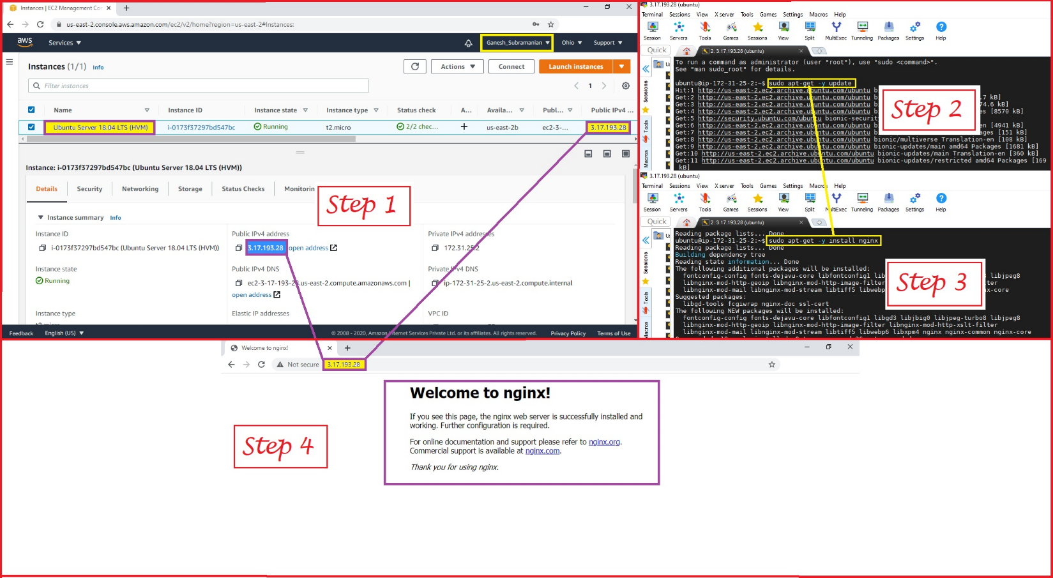

Step 1: - Created an instance using AMI: Ubuntu Server 18.04 LTS (HVM)

Step 2: - The command used for updating (sudo apt-get -y update)

Step 3: - The command used for installing ngnix (sudo apt-get -y install nginx)

Step 4: - Using the Public IP (highlighted in the above Screenshot) the Welcome to ngnix Web page

was called successfully in the Browser

**PROJECT 3**

* **Working with volumes**

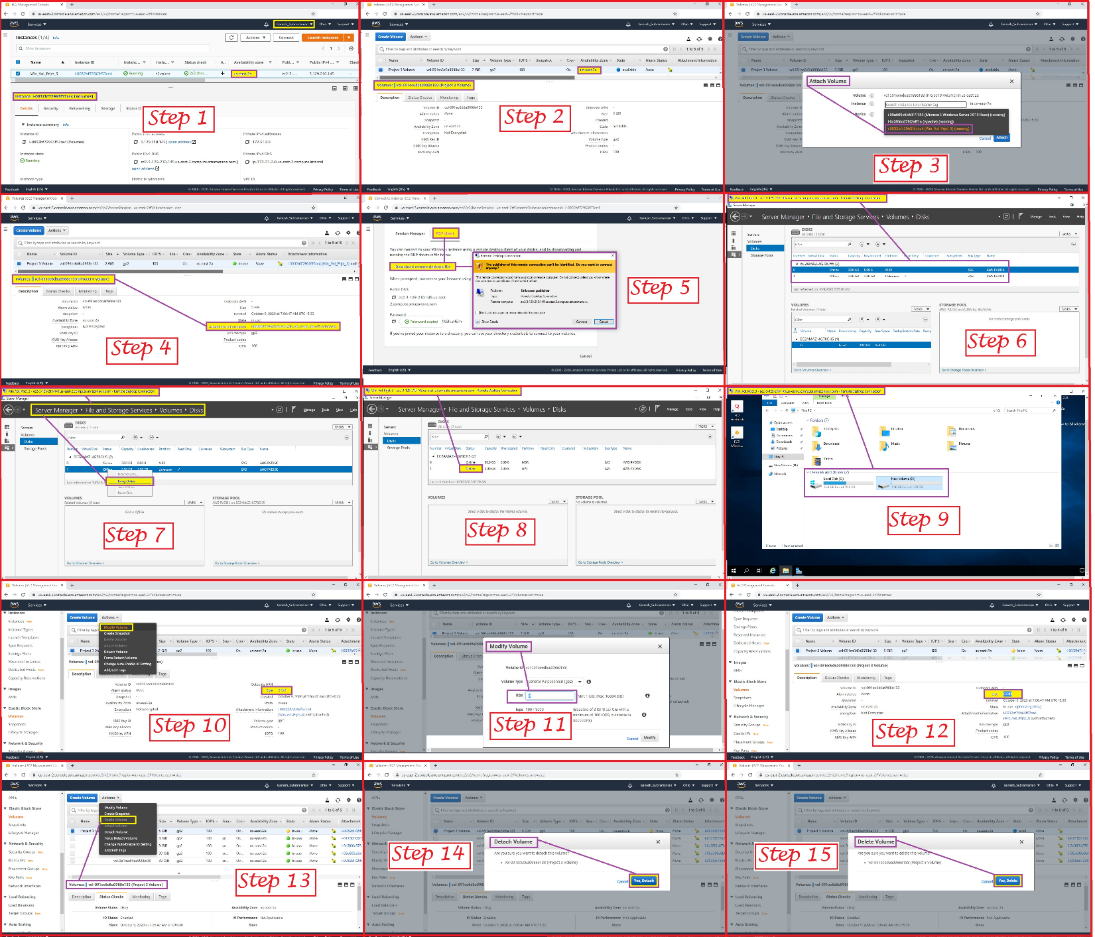

Step 1: - Created a Windows machine

Step 2: - Created a volume in the same region as the windows machine (us-east-2a)

Step 3: - Attaching of the volume to the windows machine

Step 4: - It shows the successful attachment of Volume to the machine as highlighted in the

screenshot

Step 5: - Connecting the Instance using the RDP Client Option.

Step 6: - On successful access to RDP, the required Disk Details are displayed as highlighted in the

screenshot

Step 7: - From the server manager bringing the volume online

Step 8: - Displays the Successful Online view as highlighted in the screenshot

Step 9: - Displays the Disk Drive details as highlighted in the screenshot

Step 10: - Trying to Modify the Volume details by using the Modify Volume option

Step 11: - Modification of details (i.e. from existing 2GB to 5GB Disk Size)

Step 12: - Successful Modification of Volume details as the updated details are being

displayed in the disk size (5GB)

Step 13: - Deletion of the created Volume

Note: -

Unable to delete directly hence had to detach the volume and then delete it

Step 14: - Detaching the created Volume

Step 15: - Once Detached the Volume the Deletion process was successful

**PROJECT 4**

* **Working with Elastic IP's**

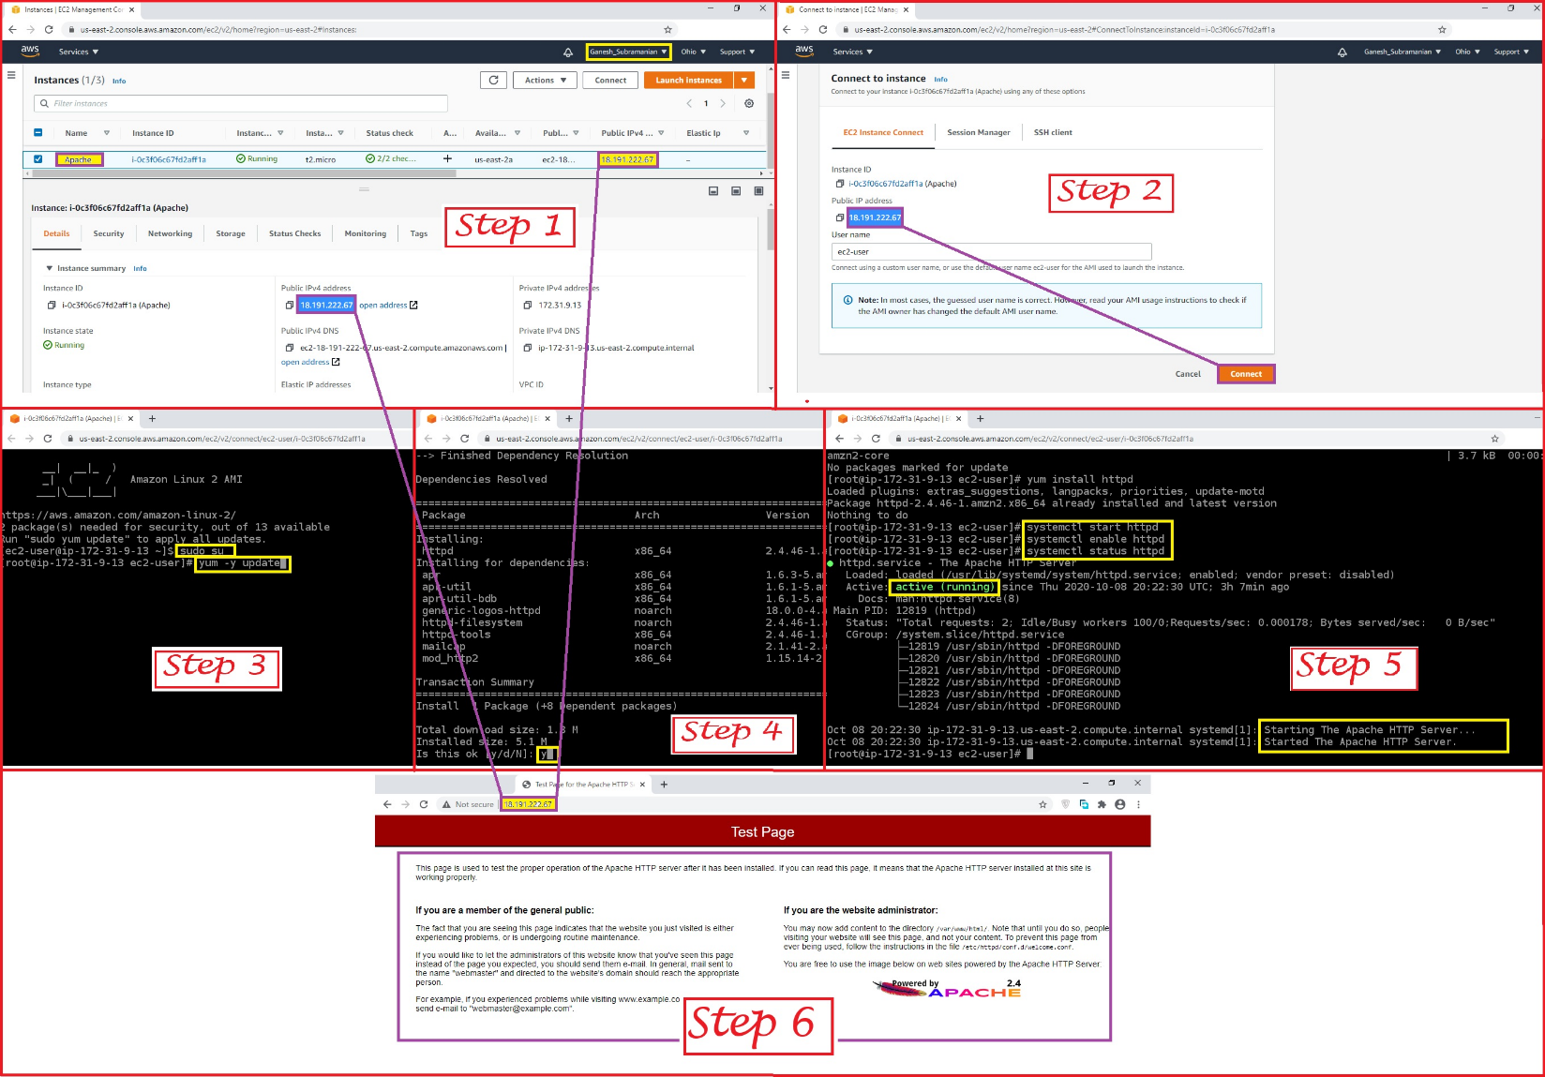

Step 1: - Created a new EC2 Instance

Step 2: - Connecting the newly created EC2

Step 3: - For Switching to Root User the command used (sudo –su)

For running the required available updates, the command used (yum -y update)

Step 4: - For installing Apache Webserver the command used (yum install httpd)

On prompt Type “Y” to proceed

Step 5: - For Starting the Web Server, the command used (systemctl start httpd),

For Enabling the Httpd, the command used (systemctl enable httpd),

For Checking the web server Status, the command was used (systemctl status httpd)

and the Active (running) Status is also observed.

Step 6: - Using the Public IP (highlighted in the above Screenshot) the Apache test page was called

successfully in the Browser

**PROJECT 5**

* **Working with S3**

a). **Working with S3-.jpg**

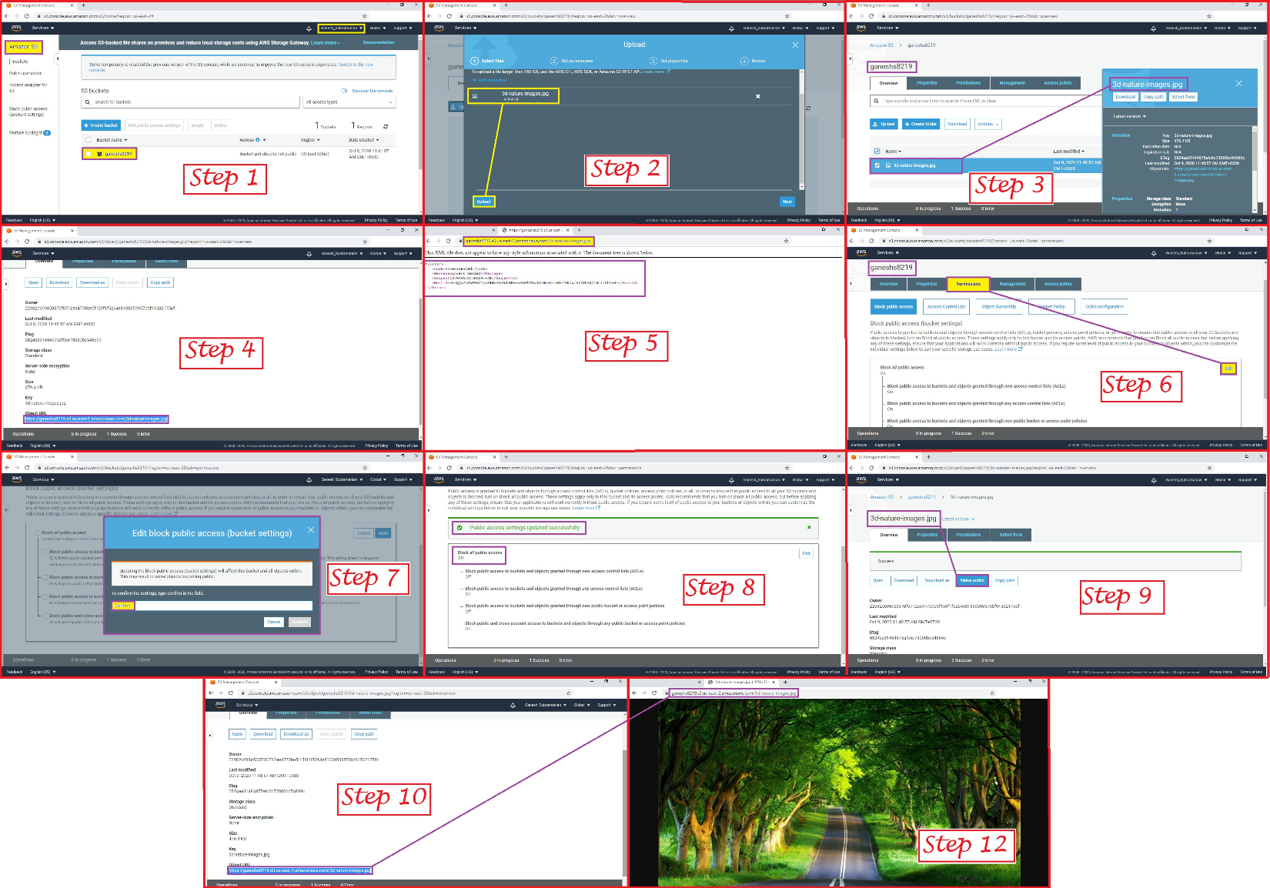

Step 1: - In Amazon S3 Console a New Bucket is created with the name of ganesh8219

Step 2: - Upload an image file in the above created bucket from the Local folder

Step 3: - IT displays the uploaded image file

Step 4: - Access the “Object URL” by pasting the URL in the browser

Step 5: - Access Denied message displayed on the browser

Step 6: - Select the “Permissions” option of the same Bucket (ganesh8219) and Click on Edit button

Step 7: - Uncheck the “Block all public access” check box and Click on Save button, a Prompt for

confirming the same would be displayed, Type “confirm” (all in small case), only then the Confirm button

would be enabled. Click on the Confirm button.

Step 8: - The Public access settings updated successfully message would be displayed

Step 9: - Click on Overview Tab, and go into the object, click on “Make Public”

Step 10: - Now Try to access the Object URL

Step 11: - The image file is displayed successfully on the browser

b). **Static Web Hosting**

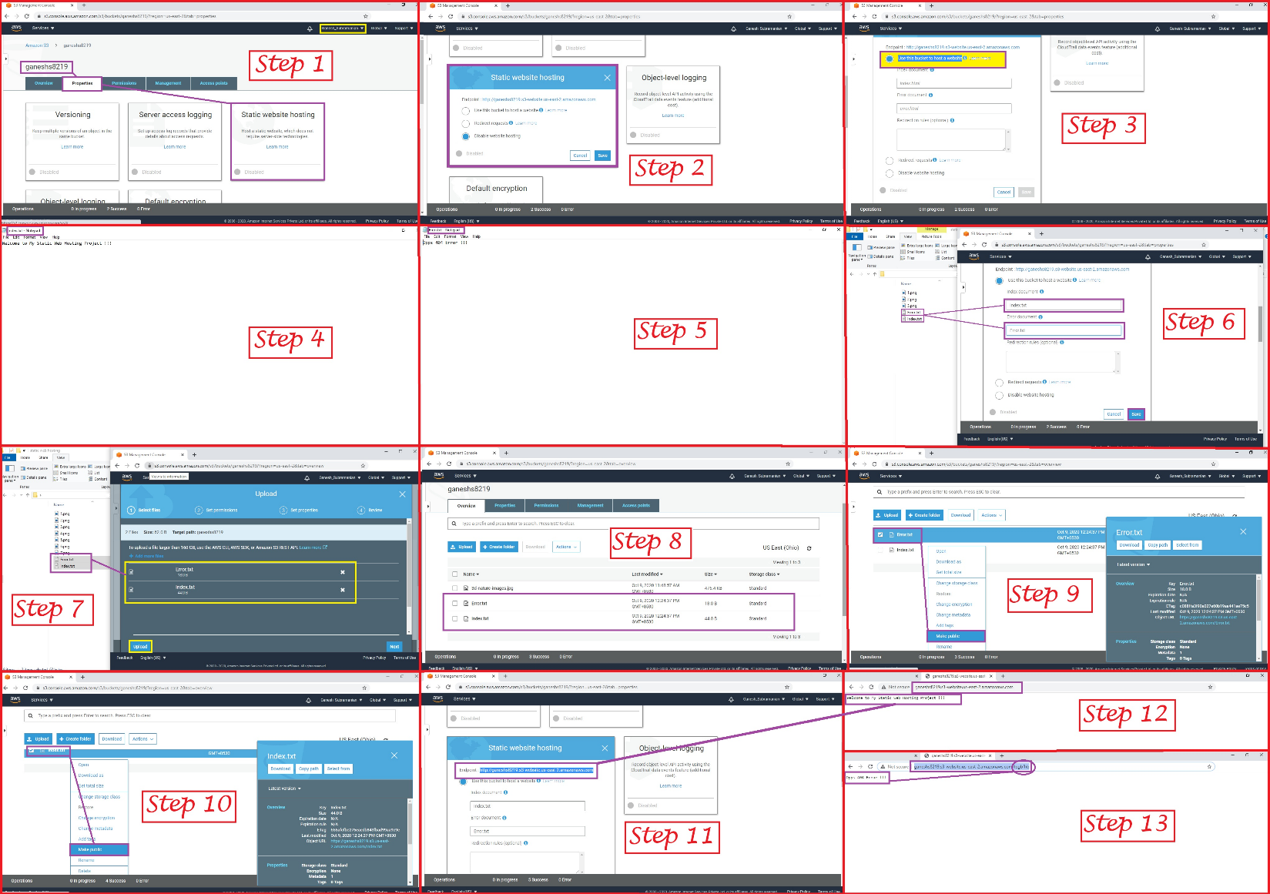

Note: -

Presuming that in Amazon S3 Console a New Bucket is created with the name of ganesh8219

Step 1: - Go into the bucket and click on Properties and Click on Static Web hosting

Step 2: - Static Web Hosting windows is displayed with options provided to select by User

Step 3: - Select the radio button: - “Use this bucket to host a website “

Step 4: - Create a Text file named as “index.txt”

Step 5: - Create a Text file named as “Error.txt”

Step 6: - Type “Index.txt” & “Error.txt” in the respective highlighted fields (index.txt in index

Document field and Error.txt in Error Document field) and Click on Save button

Step 7: - In Overview Tab upload both the files (index.txt and Error.txt) and Click on Upload button

Step 8: - Both the uploaded files would be visible

Step 9: - Make the Error.txt file as Public

Step 10: - Make the Index.txt file as Public

Step 11: - Try accessing the Endpoint URL of Static Website Hosting section of the same bucket

Step 12: - Welcome to My Static Web Hosting Project !!! page is displayed

Step 13: - Now Type some invalid values after the URL by inserting a /

(slash) and press Enter “Oops 404 Error !!!” is displayed

c). **Versioning**

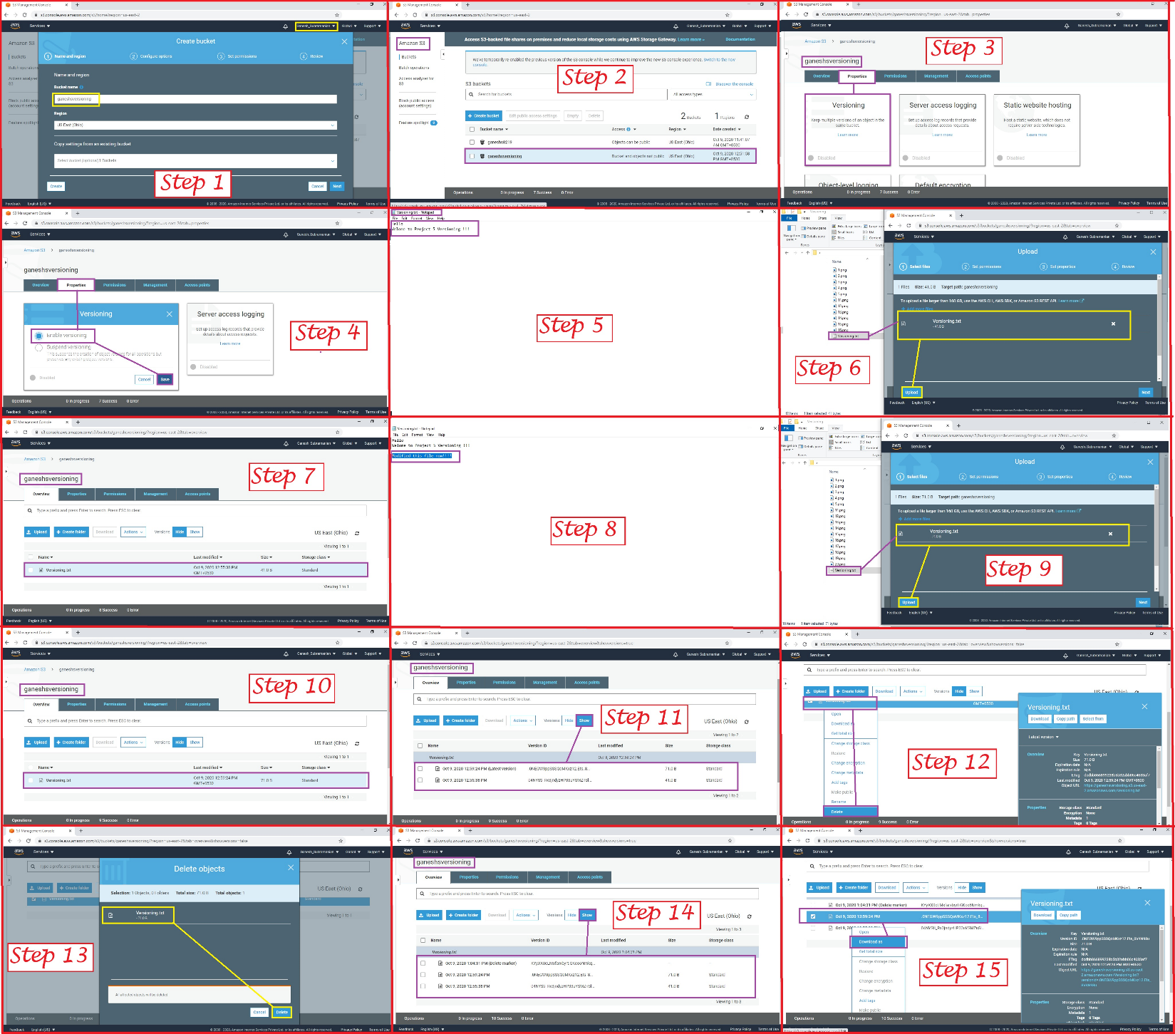

Step 1: - Create a New Bucket: - ganeshsversioning

Step 2: - The Newly Created bucket is reflected with the details

Step 3: - Go to Properties and Select Versioning box

Step 4: - Select “Enable Versioning” option and save the same

Step 5: - Create a Txt File (Versioning.txt) and Edit the file with the contents (Hello Welcome to

Project 5 Versioning !!!)

Step 6: - Upload the same file via upload options

Step 7: - The uploaded file is reflected with the details

Step 8: - Add an additional line of content in the same Versioning.txt file which was uploaded

(Modified this filed now !!!) and save the file.

Step 9: - Upload the same edited file again using Upload option

Step 10: - Should be able to see only one file only

Step 11: - Click on Show button, there would be two different version of the same file, Then Click on

Hide Version

Step 12: - Hide the version and then Right Click and Click on Delete option

Step 13: - Delete Object window is shown and Click on Delete button

Step 14: - Click on Show Version button again, you will still be able to see all the versions listed down

Step 15: - Now try to download the file as a backup

Now we can try to upload the same file again it would become another version of the same object until and unless the file name is same

**QUESTION 1:**

Explain life cycle effects on instances: Stop, Start, Reboot, Terminate, Public IP, Private IP, Applications installed.

Answer: -

Life cycle of instance

**Stop** - Server will be shut down, storage will be charged

**Start -** Command to power on server which is right now powered off, compute and

storage will be charged

**Reboot** - System will be restarted. Compute and storage will continue to charged.

**Terminate** - Releasing the resources occupied. This will shut down and delete the instance.

Data would be wiped of delete on termination is selected.

**Public IP** - IP address accessible from internet.

**Private IP** - IP address assigned from the subnet of vpc.

**Application installed** - On instances can be accessed from Public if exposed on internet. If not exposed, then can be accessed within AWS infrastructure.